Function Details
Preconditions
- The System Admin is signed in to BPMS.
- The route is protected by the sign-in guard and the admin guard; other roles cannot open it.
- Employees have been imported so that accounts can be linked to them.
Process
1. Access Account Screen:
- The System Admin opens System admin > Accounts from the sidebar.
2. Load Data:
- The system sends requests to GET /user-accounts (page 1, 20 per page), GET /user-accounts/summary, and loads the role and department lists for the filters.
3. Retrieve Account Information:
- The server returns the accounts with username, employee code, full name, department, position, role, status and last login time, plus the count of active accounts, locked accounts and employees without an account.
4. Display Summary Cards:
- The system displays three cards: "Active", "Locked" and "Employees without an account"; clicking Active or Locked filters the list by that status, and "View" on the third card opens the create account dialog.
5. Display Account Table:
- The system displays the accounts in a table with the status shown as Active, Locked or Left company, a "{from}–{to} / {total} accounts" range, page numbers and a page size of 20, 50 or 100.
6. Search and Filter:
- The System Admin searches by username, employee code or name, or filters by role, department and status; the list reloads from page 1.
7. Select an Action:
- The System Admin clicks "View" to open the account details (SCR-ADM-02), "Edit" to change the role (SCR-ADM-02-M1), or "+ Create account" to open SCR-ADM-01-M1. Accounts of employees who left show only "View".
Postconditions
- The System Admin views the accounts that match the search and filters.
- Selecting View, Edit or Create account opens the corresponding drawer or dialog.
- Accounts cannot be deleted from this screen.
Error Handling
- No Matching Accounts: Display "No matching accounts." in the table.
- Accounts Could Not Be Loaded: Display "Could not load accounts." with a "Retry" button.
- Filters Could Not Be Loaded: Display "Could not load roles or departments for filtering."
- Summary Unavailable: The summary cards show "—" instead of a number.
- Unauthorized Access: Users who are not signed in are redirected to the sign-in page; non-admin users are blocked by the admin guard.
Security Measures
- Only signed-in System Admins can open the screen (authGuard + adminGuard).
- Account data, counts and statuses are always loaded from the server.
- Accounts of employees who left the company are view-only and cannot be edited.

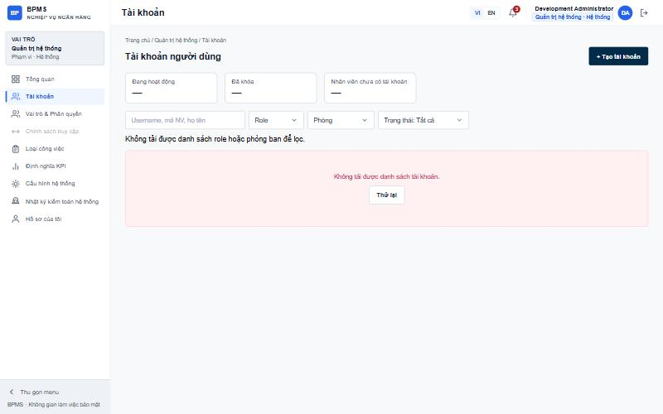
Figure: SCR-ADM-01 User Account List

Function Details
Preconditions
- The System Admin is on the User Account List screen.
- At least one active employee does not have an account yet.
Process
1. Open Create Dialog:
- The System Admin clicks "+ Create account" (or "View" on the Employees without an account card).
2. Load Eligible Employees:
- The system sends a request to GET /user-accounts/eligible-employees; only active employees without an account are listed.
3. Select Employee:
- The System Admin selects an employee; the system shows the department, position, email and source, and pre-fills the suggested username and the role suggested for the position.
4. Enter Account Information:
- The System Admin reviews or changes the username and role. "Force password change at first sign-in (required)" is always checked.
5. Submit:
- The System Admin clicks "Create (Ctrl+S)"; the system validates the form and sends POST /user-accounts with the employee, username, role and must-change-password flag.
6. Show Temporary Password:
- The system displays "Account {username} created" with the temporary password and a "Copy" button. The password is shown only once; the system does not send e-mail.
7. Finish:
- The System Admin clicks "Done"; the list and summary cards reload.
Postconditions
- A new account linked to the selected employee is created with a temporary password.
- The user must change the password at first sign-in.
- Clicking "Cancel" or pressing Esc closes the dialog without saving.
Error Handling
- Required Fields: Display "This field is required." under an empty employee, username or role.
- Invalid Username: Display "Username uses lowercase letters, digits, dot, underscore or hyphen (3–50 characters)."
- Username Already Exists: Display "Username already exists." (USERNAME_EXISTS).
- Employee Already Has an Account: Display "This employee already has an account." (ACCOUNT_EXISTS).
- No Eligible Employees: Display "Every employee already has an account."
- Save Failed: Display "Could not save. Please try again."
Security Measures
- Only System Admins can create accounts.
- Passwords are generated by the system, never typed by the admin, and the temporary password is displayed only once.
- Uniqueness of username and one-account-per-employee is enforced on the server.

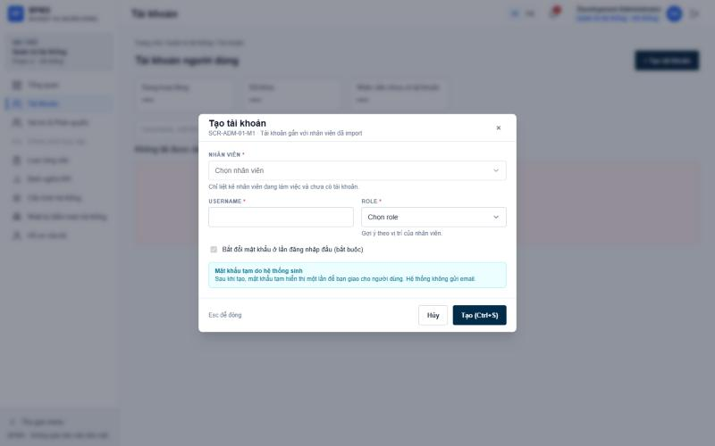
Figure: SCR-ADM-01-M1 Create Account

Function Details
Preconditions
- The System Admin is on the User Account List screen.
- The selected account exists.
Process
1. Open Details:
- The System Admin clicks "View" on an account row.
2. Load Account Details:
- The system sends a request to GET /user-accounts/{id} and opens a drawer beside the list.
3. Display Information Tab:
- The system shows the username, status, the linked employee (name, employee code, department) with an "Open profile" link, and the account role, last login, creation date and creator, and password last changed date, plus the 3 most recent history entries.
4. Display History Tab:
- The System Admin opens "History" to see all events with time, event and actor.
5. Choose an Action:
- The System Admin can click "Edit" (SCR-ADM-02-M1), "Reset password" (SCR-ADM-02-M2) or "Lock account" (SCR-ADM-02-M3), or open the employee profile.
6. Close Drawer:
- The System Admin clicks × or presses Esc to close the drawer.
Postconditions
- The System Admin views the full account information and history.
- "Open profile" navigates to the employee detail page.
Error Handling
- Details Could Not Be Loaded: Display "Could not load account details." with a "Retry" button.
- No History: Display "No change history yet."
Security Measures
- Only System Admins can view account details.
- Accounts of employees who left are view-only: Edit and Lock are hidden.

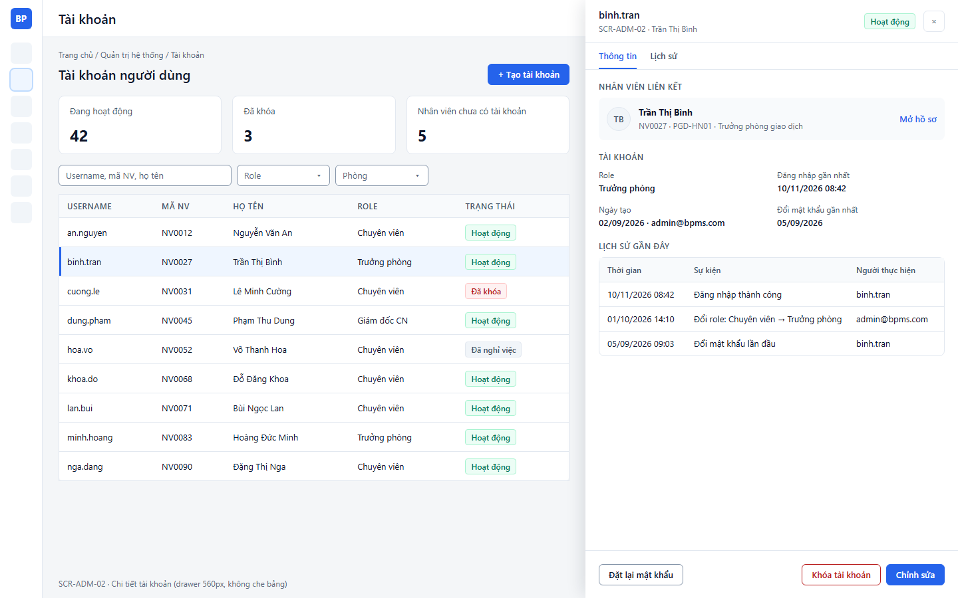
Figure: SCR-ADM-02 User Account Details (low-fi mockup)

Function Details
Preconditions
- The System Admin has opened an account whose status is not Left company.
Process
1. Open Edit Dialog:
- The System Admin clicks "Edit" on the list row or in the details drawer.
2. Display Current Account:
- The system shows the employee and username as read-only and the current role selected.
3. Change Role:
- The System Admin selects a new role; if it differs from the role suggested for the position, the system shows the warning "Role does not match position".
4. Save:
- The System Admin clicks "Save (Ctrl+S)"; the system sends PUT /user-accounts/{id} with the new role.
5. Refresh:
- The dialog closes and the details, list and summary cards reload.
Postconditions
- The account role is updated; the menu and KPIs the user sees follow the new role.
- Department and position are not edited here; they only change through employee import.
Error Handling
- Role Not Selected: Display "This field is required."
- Save Failed: Display "Could not save. Please try again."
Security Measures
- Only System Admins can change roles.
- Accounts of employees who left cannot be edited.

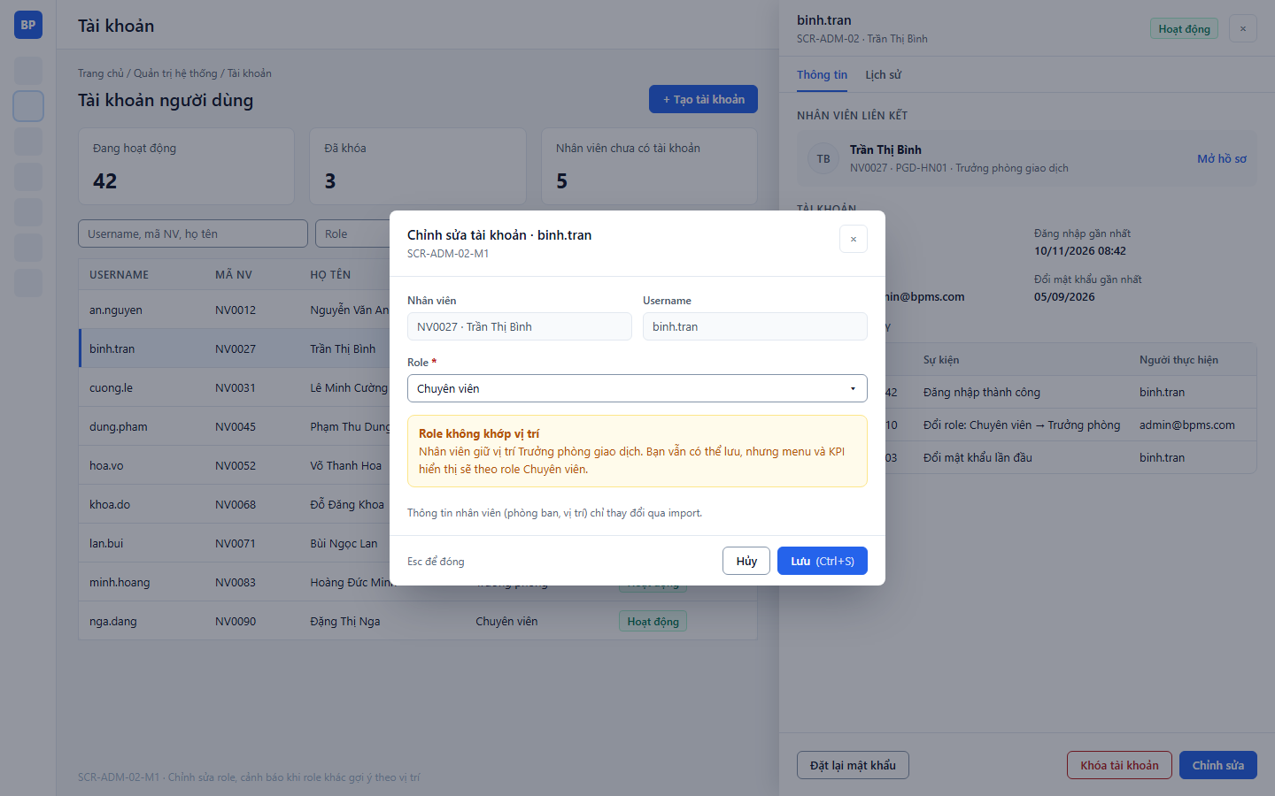
Figure: SCR-ADM-02-M1 Edit Account (low-fi mockup)

Function Details
Preconditions
- The System Admin has opened an account in the details drawer.
Process
1. Request Reset:
- The System Admin clicks "Reset password" in the drawer footer or in the row ⋯ menu.
2. Current Behaviour:
- The button is disabled with the tooltip "Not supported yet"; no reset dialog or API exists yet.
Postconditions
- No change is made to the account in the current version.
Error Handling
- Function Not Available: The tooltip "Password reset and lock/unlock are not supported yet" is shown.
Security Measures
- When implemented, only System Admins should reset passwords, and a new temporary password should be generated by the system.

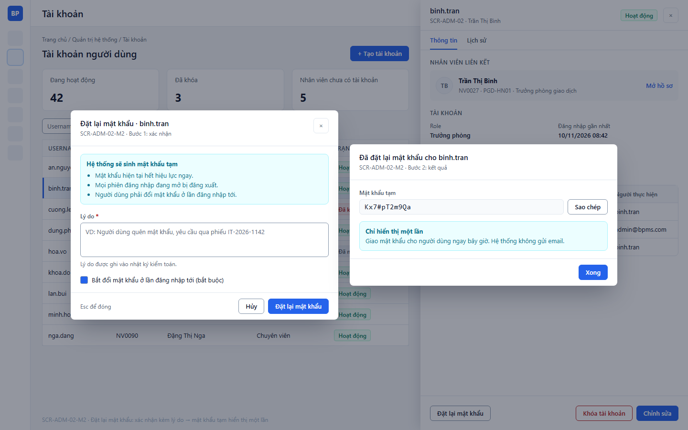
Figure: SCR-ADM-02-M2 Reset Password (low-fi mockup)

Function Details
Preconditions
- The System Admin has opened an account whose status is not Left company.
Process
1. Request Lock:
- The System Admin clicks "Lock account" in the drawer footer or in the row ⋯ menu.
2. Current Behaviour:
- The button is disabled with the tooltip "Not supported yet"; no lock dialog or API exists yet.
Postconditions
- No change is made to the account in the current version.
Error Handling
- Function Not Available: The tooltip "Password reset and lock/unlock are not supported yet" is shown.
Security Measures
- When implemented, only System Admins should lock or unlock accounts, and locked accounts must be rejected at sign-in.

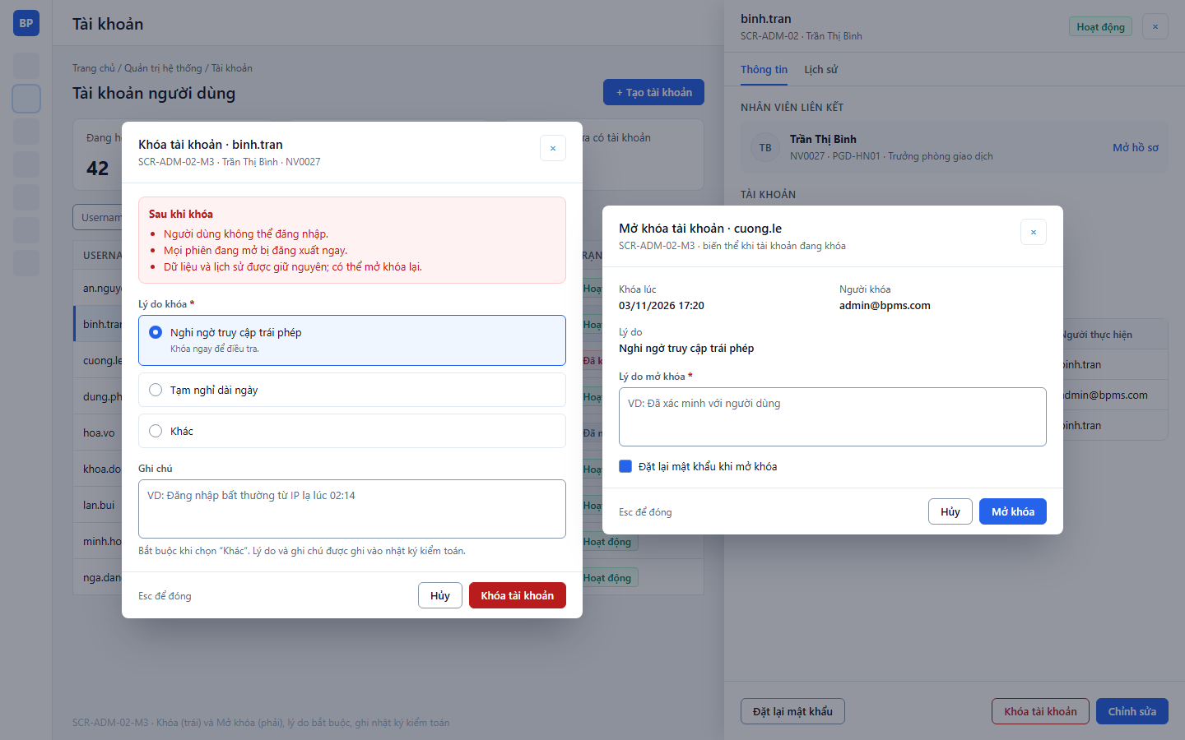
Figure: SCR-ADM-02-M3 Lock / Unlock Account (low-fi mockup)

